Jessica Curran

Git 1

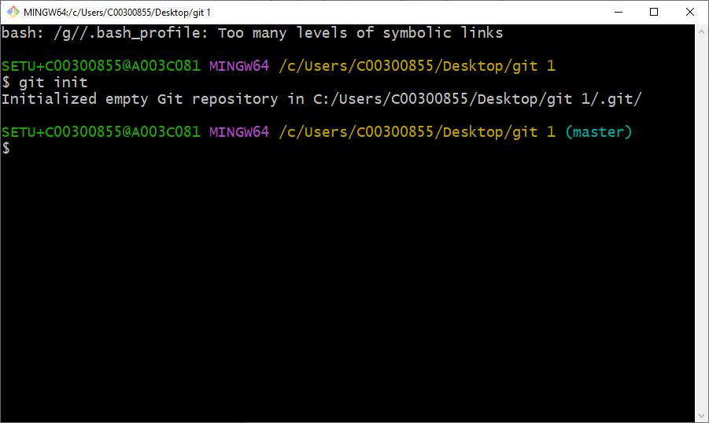

git init = this initialises the repository on the local system file.

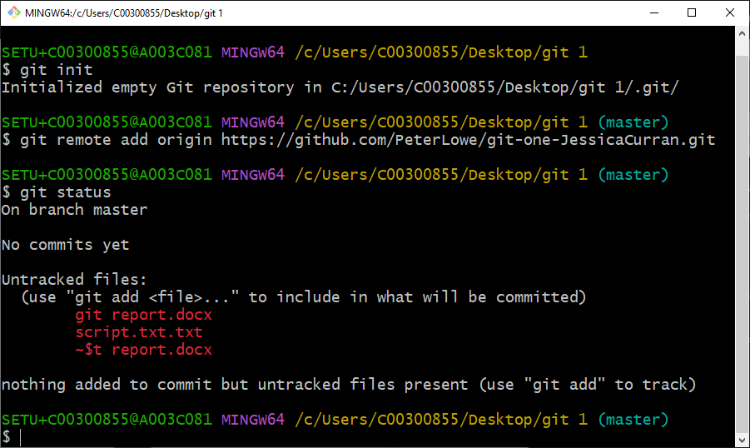

git status = checking what files are committed to the repository

git remote= connecting the remote repository to this git bash

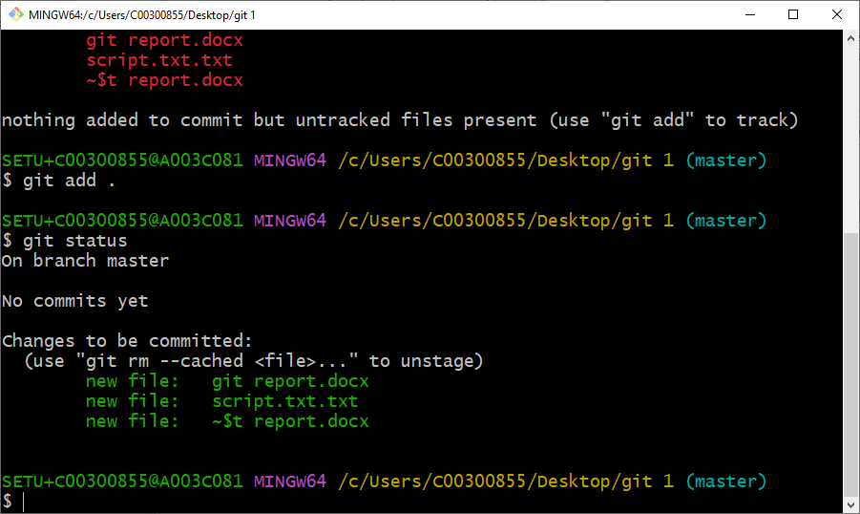

git add= added all the files in the selected folder to the repository

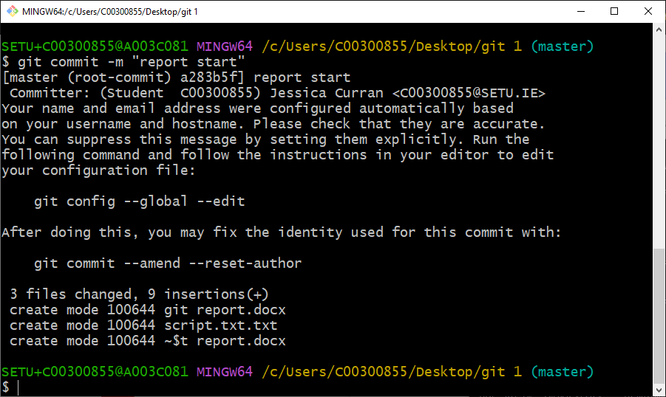

git commit = committing the files in the folder to the remote repository.

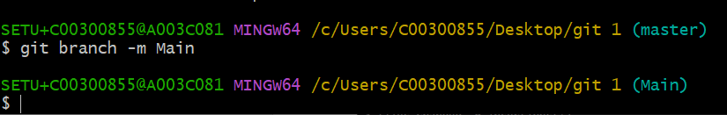

git branch= created this branch for a push command

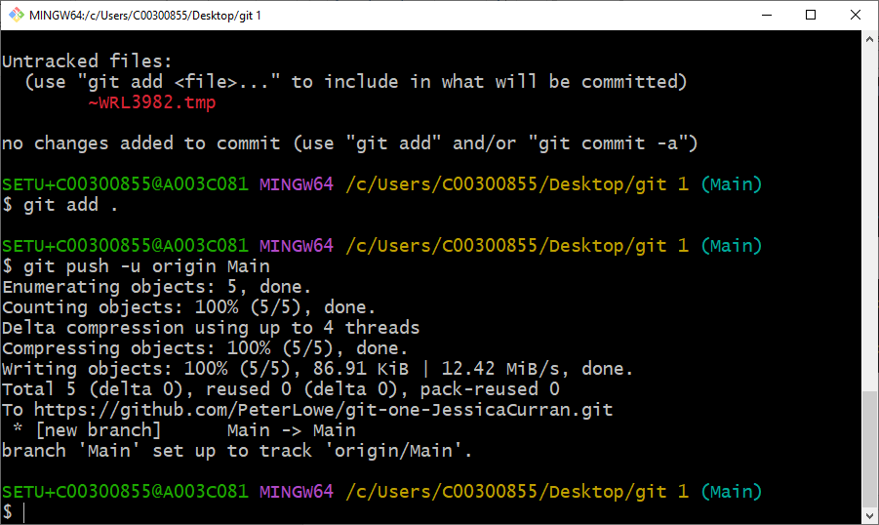

git push= this is to push the default branch main

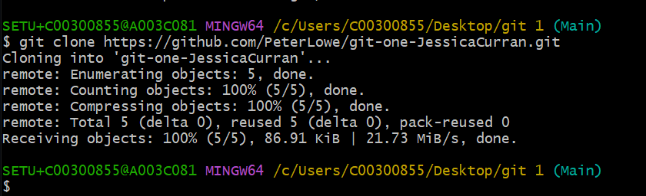

git clone= this was to clone my repository in use in-case of a crash.